Dataset: combined_csv_v220 which is the 20% from the original dataset of combined_csv_v2

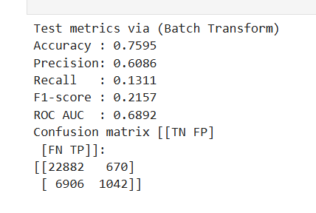
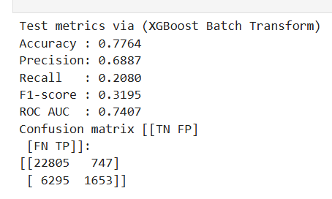
Model Evaluation

The XGBoost model did better than the Linear model on most criteria. The XGBoost model had better overall prediction power, even though both models were about 0.76–0.78 accurate. The ROC-AUC went up from 0.6892 to 0.7407, which means that XGBoost is better at telling the difference between delayed and non-delayed aircraft. The accuracy also went up from 0.6086 to 0.6887, which means that XGBoost makes less wrong predictions about delays. The most essential thing is that the recall went up from 0.1311 to 0.2080, which means it catches more real delayed flights, which is very critical for this business problem. The F1-score went up from 0.2157 to 0.3195, which means that there was a better balance between precision and recall.
XGBoost found more true positives (1653 vs. 1042) and a few fewer false negatives in the confusion matrix. However, it also found a few more false positives (747 vs. 670). This trade-off is okay because finding additional possible delays fits with the business purpose of giving clients early warning.

Dataset: combined_csv_v120 which is the 20% from the original dataset of combined_csv_v1
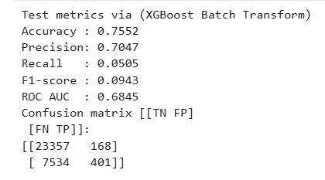
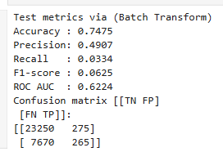
The Linear model still has lack behind with low recall, but the XGBoost model does better than the Linear model again. The accuracy went up a little, from 0.7475 to 0.7552, which means that XGBoost makes less mistakes overall. The accuracy went up from 0.4907 to 0.7047, which means that XGBoost is right almost 70% of the time when it says a flight will be late. This is a big improvement. But recall is still rather poor (from 0.0334 to 0.0505), which shows that both models still miss most of the real delay cases.
The F1-score went up from 0.0625 to 0.0943, and the ROC-AUC went up from 0.6224 to 0.6845. This means that it was better at telling the difference between delayed and non-delayed aircraft. XGBoost finds more true positives (401 vs. 265) and fewer false positives (168 vs. 275) in the confusion matrix. This shows a minor but significant improvement in discovering real delays while keeping false alarms low.

At conclusion, I have to say that XGBoost model is better at classifying things overall than the linear model since it has higher precision, F1-score, and ROC AUC.

Github Link: https://github.com/AyushBajgai/Predicting-Airplane-Delays-using-ML-pipeline

Tableau Link: https://prod-apsoutheast-a.online.tableau.com/#/site/ayushbajgai01-058cb059f4/workbooks/2469096?:origin=card_share_link

